Lab 02

ECE 380-002

University of Alabama

Yichen Huang

Thomas Dillman

2019/09/09

**Introduction**

This laboratory has two parts. The first part aims at building a simple circuit by VHDL and Schematic file through a truth table. In the second part, we upload the file done by the part one to the Altera’s DE1 board.

**Procedure**

1. Part I
   1. Design A

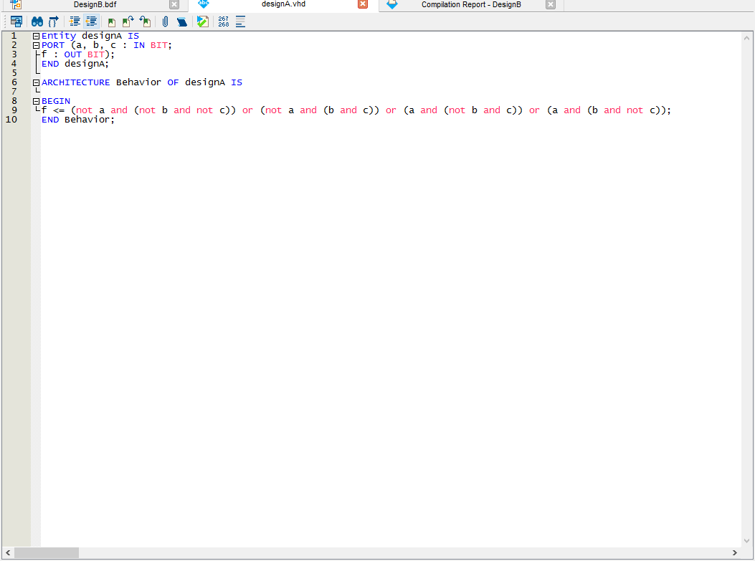Before the lab, our team have figured out the function by Max Term (POS). Then on the lab, we created the VHDL File called designA.vhl (Figure 1) After the successfully compiling, we run the stimulation test, in the waveform file called designA_test.wvf. (Figure 2) we created 8 possible scenarios. The result shows that the outcome is same as the truth table.

Figure designA.vhl

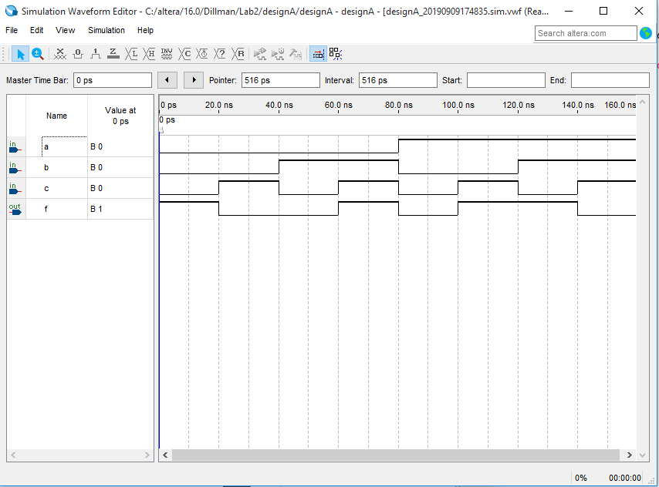

**1**

**1**

**1**

**1**

**1**

**0**

**1**

**1**

**1**

**1**

**0**

**1**

**0**

**0**

**0**

**1**

**1**

**1**

**1**

**0**

Figure 2 designA_test.wvf

**0**

**0**

**1**

**0**

**0**

**1**

**0**

**0**

**1**

**0**

**0**

**0**

* 1. Design B

In design B, we built the same circuit in design A through schematic form. We created a Body Diagram File named designB.bdf. (Figure 3) After compiling, we run the same test in the design A. The result is also same as the truth table outcome. (Figure 4)

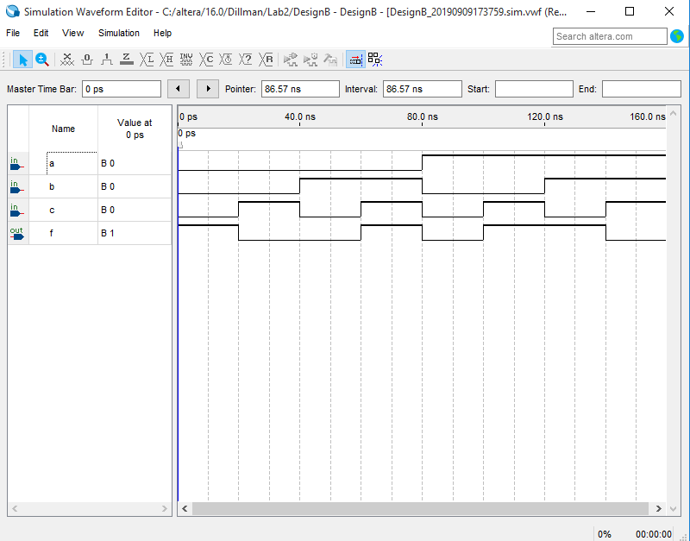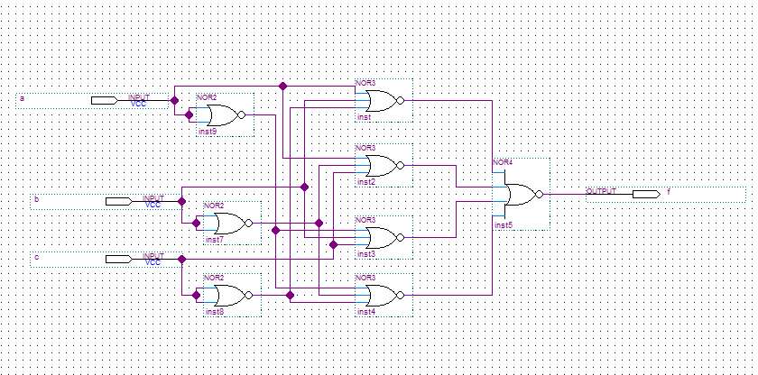

Figure 4 designB.wvf

**0**

**1**

**1**

**1**

**0**

**1**

**1**

**1**

**0**

**1**

**1**

**1**

**0**

**0**

**0**

**1**

**1**

**1**

**0**

**0**

**1**

**1**

**0**

**0**

**0**

**1**

**0**

**0**

**1**

**0**

**0**

**0**

**F:1->0->0->1->0->1->1->0**

**C:0->1->0->1->0->1->0->1**

**B:0->0->1->1->0->0->1->1**

**A:0->0->0->0->1->1->1->1**

Figure 3 designB.bdf

1. Part II

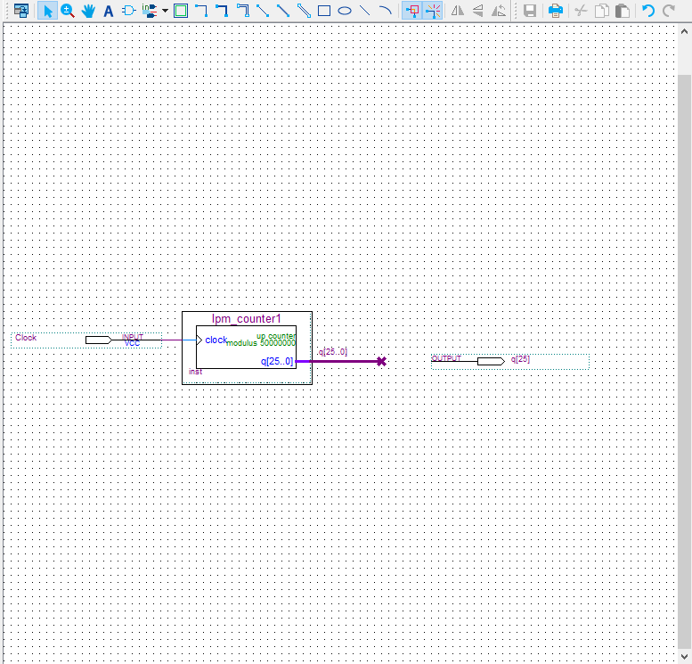We make a simple design by the guide in the lab2 assignment. We follow the instruction and configure the Altera’s DE1 board. Then create a project named frequency. We created a new BDF File named frequency.bdf. (Figure 5) After compiling, we assigned the pins on the board. (Figure 6) Then compile again, the LED on the Board is flashing, and the progress shows successful.

Figure 5 frequency.bdf

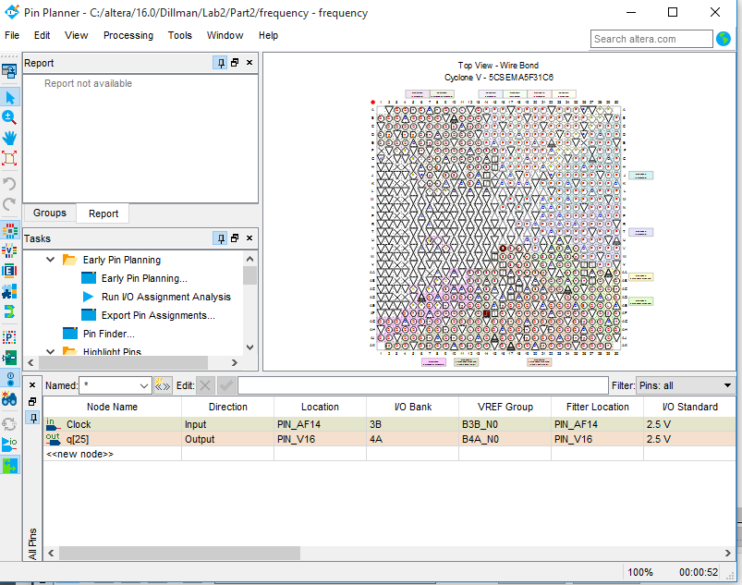

Figure 6 assign the pin

**Conclusion**

All two parts in the lab 2 are all finished successful.

Lab Score

Lab score